**PROJECT DEVELOPMENT PHASE**

**SPRINT-1 TEST CASES**

|  |  |
| --- | --- |
| Date | 01 November 2022 |
| Team ID | PNT2022TMID06561 |
| Project Name | Digital Naturalist – AI Enabled Tools for Biodiversity Researchers. |
| Maximum Marks | 8 Marks |

# Login Page

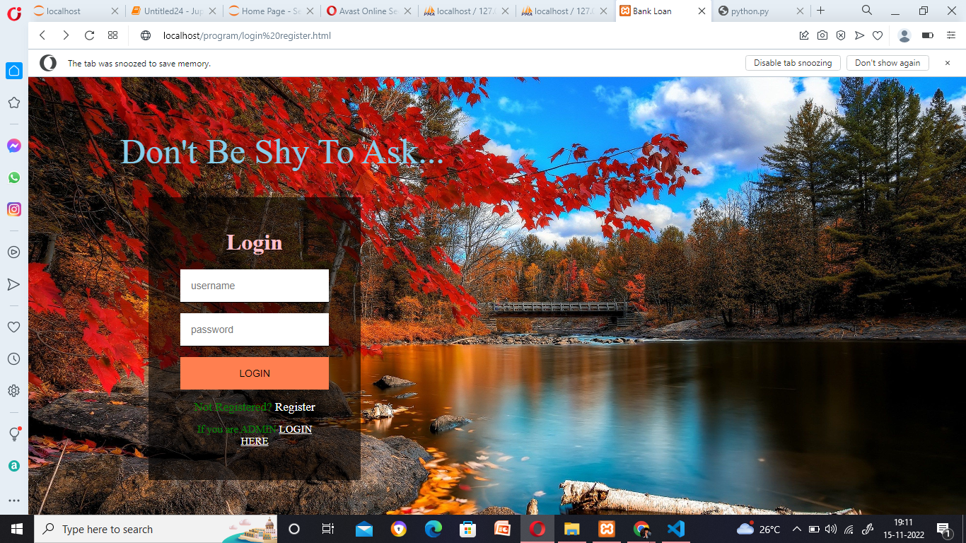

# Register Page

